Forensic Report

|  |  |
| --- | --- |
| Client: | Chris Wipat |
| Client’s Case ref: | R v Donald Sutherland |
| Case name: | Donald Sutherland |
|  |  |
| CF Case ref: | CW170101 |
| Report number: | CW13038519-01 |
| Report Author: | C Wipat |
| Report date: | 18 January 2017 |

Forensic Report

# Introduction

## For the purposes of this report, technical explanations of the various procedures and terms used will be found in the **Descriptions** Section 5. Items covered in this way will be underlined thus **EnCase®**.

# Case Background

## Following a recent statement given by a Mrs A. Sutherland implicating her husband, Mr Donald Sutherland and associate Mr Edward Robson, with several suspected car thefts in and round the Newcastle area; Northumbria Police has traced further leads into the accounts of alleged missing cars.

## Northumbria Police had previously received multiple reports of suspicious activity from an unidentified individual. Furthering reports from concerned employee's at Benfield Maserati, and the recently given statement by Mrs Sutherland, prompted for an additional investigation by Northumbria Police.

## Following the investigation and analysis of the CCTV footage provided to Northumbria Constabulary by Benfield Maserati garage; the individual was later identified as Edward Robson, associate of the accused. Other reports included local residents becoming frequently concerned about suspicious activity arising when a young male repeatedly visited properties and photographed vehicles of which had a high market value. Mr Robson was arrested and questioned about his involvement within the reported activity.

## Upon further questioning of Mr Robson in exchange for a reduced sentencing has provided further information into the activity of his accomplice Mr Sutherland; supporting Mrs Sutherlands claims into her husband's involvement.

# The Material

## All analysis was carried out using a **Forensic Workstation** (**FWS**) and software known as **EnCase®**.

## A forensic image copy, using EnCase® version 6.71, was made of the hard drive prior to any analysis being undertaken.

## All analysis was then carried out using the forensic copy in the form of an .E01 file.

# Descriptions

## **EnCase**®

Software produced by Guidance Software which provides investigators with the tools to conduct complex investigations with accuracy and efficiency. It allows completely non-invasive computer forensic investigations while allowing examiners to easily manage large volumes of computer evidence and view computer drive contents including files, operating system artefacts, file system artefacts, and deleted files or file fragments located in file slack or unallocated space.

## **Internet Evidence Finder (IEF)**

## Software produced by Magnet Forensics which provides investigators with tools to conduct complex investigations with accuracy and efficiency. IEF allows investigators a complete non-invasive full computer search for all common files and evidence possibly relevant to the forensic investigation. IEF comes with many search features such as to search for a certain type of document, including PDF files, Text files, Word Documents, Excel Documents, and much more.

## **Internet Browser**

## Software on a computing device which allows you to visit and browse webpages on the internet. The most common 3 web browsers are Internet explorer, Firefox & Google Chrome. These are created and compiled under different variants of computer code however relate with the same principles of visiting web pages and recording them in browser history.

## **Internet Browsing History**

## A data collection of webpage names, sources and times, created by an Internet Browser. Internet browsing history shows exactly what the Internet Browser has been used for and where it has visited on the web.

## **Google Search Engine**

## A search engine created by Google ™ which allows you to quickly search through the internet to find websites and information about what it is that you are looking for. It is the most common internet search engine and can find and search through millions and millions of websites located on the internet.

## **Internet Search Tabs**

## During usage of an Internet Browser, each website you visit is stored and presented in what is called a tab. Users of the Internet browser can have multiple tabs open at one time in order to effectively and efficiently search through multiple pages of the internet at the same time.

## **Central Processing Unit (CPU)**

## The Central Processing Unit (CPU), is the heart of a computing device, it is the internal hardware component which processes every bit of data necessary to compute the mathematical and electrical circuitry equations and actions required to fulfil tasks and functions in an everyday computing device.

## **Random Access Memory (RAM)**

## The Random Access Memory (RAM), is the internal component of a computing device which stores execution instructions for the CPU to retrieve and initiate; in the form of machine code. The CPU retrieves the instructions from the RAM and translates them into a binary representation of the value in order to execute the instructions in the form of sending voltage (1) and not sending the voltage (0) to millions of transistors; a series of electrical circuits.

## **E01 Image File**

## An .E01 image file is a copy of a hard drive created by EnCase®. All files are copied from the hard drive whilst preventing write access to the hard drive in order preserve evidential integrity. The files are then compressed into what we call an image of the drive.

## 

## **Compression**

## Compression is a method of reducing the representation of a value usually required to store data. For example in ASCII code, a type of machine code, values are usually represented by a 7 digit code however can be shortened to a 3 digit. Compressing a file or multiple files dramatically decreases the size required to store the data, and as such further dramatically increases the speed of transferring the required data from one location to another.

## **7-zip & .zip files**

## 7-zip is software created for the purpose of compressing files into one single file which it can then later access and un-compress/extract if desired. This software has its own file type in the name of .7zip, however it can also use much more file types, for example .zip. This software provides the capability of different compression methods among other features, such as setting a password on your compressed file. A zip is a compressed file.

## **ExifTool**

## Software created by Phil Harvey for the forensic viewing of metadata information attached to a file. On every file on a computer is contained metadata, metadata is a bundle of information about a file on a computer. This information can include such examples as creation date and time, modified date and time, last accessed date and time, creation author, file size, file type and much more. ExifTool provides a tool outside of EnCase which allows forensic practitioners the ability to securely and certifiably retrieve all information available within a file.

## **Registry**

The registry is the central hierarchical database used in all versions of the operating system Microsoft Windows. The registry is used to store information necessary to configure and as such run the operating system. The registry contains crucial information that Windows continually collocates with during operation. Examples of information contained inside the registry can include the profiles for each user account on the system, applications installed on the computer, types of documents that each user can create, what hardware exists on the system, and much, much more.

Section 1 – PC System Information

Windows Initialize Case

Donald Sutherland Home Computer - C

*Serial Number: A883-3C30*

*Full Serial Number: 9CA88364A8833C30*

*Driver Information: NTFS 3.1 (4000)*

*Volume*

*File System: NTFS*

*Sectors per cluster: 8*

*Bytes per sector: 512*

*Total Sectors: 156,297,216*

*Total Capacity: 80,024,170,496 Bytes (74.5GB)*

*Total Clusters: 19,537,151*

*Unallocated: 55,545,094,144 Bytes (51.7GB)*

*Free Clusters: 13,560,814*

*Allocated: 24,479,076,352 Bytes (22.8GB)*

*Volume Offset: 2,048*

*ID: S-1-5-21-601739683-2125448060-1724766464*

*Drive Type: Fixed*

Partition

*ID: 07*

*Type: NTFS*

*Start Sector: 2,048*

*Total Sectors: 156,297,216*

*Size: 74.5GB*

Case Info

*Name: Donald Sutherland Home Computer*

*ActualDate: 24/01/14 09:33:23*

*TargetDate: 24/01/14 09:33:23*

*FilePath: R:\CM0583\Assessment\1617\HDD\WMAMD1936927.E01*

*Case Number: RS_CM0664_01*

*Evidence Number: S-R#1*

*Examiner Name: Group A*

*Notes:*

*Drive Type: DRIVEFIXED*

*File Integrity: Completely Verified, 0 Errors*

*Acquisition Hash: 2817DD62B0F83E0DBF765A1E08E2FF2A*

*Verify Hash: 2817DD62B0F83E0DBF765A1E08E2FF2A*

*EnCase Version: ADI3.1.3.2*

*System Version: Windows 7*

*Fastbloced: No*

*Is Physical: Yes*

*Compression: None*

*Total Sectors: 156301488*

Section 2 – Evidence

**1) Assignment\Donald Sutherland Home Computer \C\Users\Donald Sutherland \AppData\Local\Google\ Chrome\User Data\Default\History**

Using Internet Evidence Finder to carry out a non-invasive and write-protected search through a copy/image of Donald Sutherland’s computer, the following has been found.

**i) Google Search - *“how to steal a car"***

*URL:*

[*https://www.google.co.uk/search?q=how+to+steal+a+car&oq=how+to+steal+a+car&aqs=chrome..69i57j0l5.7962j0j7&sourceid=chrome&espv=210&es_sm=93&ie=UTF-8%20–%20a”%20*](https://www.google.co.uk/search?q=how+to+steal+a+car&oq=how+to+steal+a+car&aqs=chrome..69i57j0l5.7962j0j7&sourceid=chrome&espv=210&es_sm=93&ie=UTF-8%20–%20a)

*Date Visited Date/Time - (UTC) (dd/MM/yyyy) 14/11/2013 11:58:43*

*Title: how to steal a car - Google Search*

*Typed Count: 0*

*Transition Type : GENERATED*

*Visit Source: (not found)*

*Table: visits(id: 944), Table: urls(id: 649)*

*Evidence Number WMAMD1936927*

*Source: WMAMD1936927.E01 - Partition 1 (Microsoft NTFS, 74.53 GB) (All Files and Folders) - [ROOT]\Users\Donald Sutherland\AppData\Local\Google\Chrome\User Data\Default\History*

The above search shows contents of a file named “History” as stored in the location of Donald Sutherland’s computer at: **C:\Users\Donald Sutherland\AppData\Local\Google\Chrome\User Data\Default\History**.

This file has been automatically created by Google Chrome, a web browser installed on Donald Sutherland’s computer, with the intent of collecting and storing Internet Browser History. The search shows that at 11.58am on the 14th November 2013, Donald Sutherland has visited the webpage:

*“*[*https://www.google.co.uk/search?q=how+to+steal+a+car&oq=how+to+steal+a+car&aqs=chrome..69i57j0l5.7962j0j7&sourceid=chrome&espv=210&es_sm=93&ie=UTF-8 – a*](https://www.google.co.uk/search?q=how+to+steal+a+car&oq=how+to+steal+a+car&aqs=chrome..69i57j0l5.7962j0j7&sourceid=chrome&espv=210&es_sm=93&ie=UTF-8%20–%20a)*”*

This webpage as we can see is Google™ Search Engine. The above link initiates a search for the keywords “how to steal a car”. This relates directly to this case because it shows that the accused Donald Sutherland has used to Google to look for ways on how to a steal car, one of the exact crimes of which he is being accused of; theft.

***ii)* Google Search - *“benfield maserati newcastle”***

*URL:* [*https://www.google.co.uk/search?q=benfield+maserati+newcastle&oq=benfield+mas&aqs=chrome.2.69i57j0l4.4889j0j4&sourceid=chrome&espv=210&es_sm=93&ie=UTF-8*](https://www.google.co.uk/search?q=benfield+maserati+newcastle&oq=benfield+mas&aqs=chrome.2.69i57j0l4.4889j0j4&sourceid=chrome&espv=210&es_sm=93&ie=UTF-8)

*Date Visited Date/Time - (UTC) (dd/MM/yyyy) 14/11/2013 12:30:14*

*Title benfield maserati newcastle - Google Search*

*Typed Count 0*

*Transition Type GENERATED*

*Visit Source (not found)*

*Table: visits(id: 1014), Table: urls(id: 693)*

*Evidence Number WMAMD1936927*

*Source WMAMD1936927.E01 - Partition 1 (Microsoft NTFS, 74.53 GB) (All Files and Folders) - [ROOT]\Users\Donald Sutherland\AppData\Local\Google\Chrome\User Data\Default\History*

The above shows a Google Search for a Benfield Maserati; as stored by a Benfield Maserati garage in Newcastle whose employees have reported multiple occasions of suspicious activity regarding an individual who was later identified as the accused’s associate; Edward Robson. This google search was retrieved from the same location as the previous Google Search as shown in the source information: **C:\Users\Donald Sutherland\AppData\Local\Google\Chrome\User Data\Default\History.**

**iii) Google Search – *“alfa romeo”***

[*https://www.google.co.uk/search?q=alfa+romeo&espv=210&es_sm=93&source=lnms&tbm=isch&sa=X&ei=prNzUsiHJoqmhAfS2YFg&ved=0CAkQ_AUoAQ&biw=1280&bih=880*](https://www.google.co.uk/search?q=alfa+romeo&espv=210&es_sm=93&source=lnms&tbm=isch&sa=X&ei=prNzUsiHJoqmhAfS2YFg&ved=0CAkQ_AUoAQ&biw=1280&bih=880)

*URL:*

*Last Visited Date/Time - (UTC) (dd/MM/yyyy) 01/11/2013 13:59:04*

*Title: alfa romeo - Google Search*

*Visit Count: 1*

*Typed Count: 0*

*Located At: Table: urls(id: 357)*

*Evidence Number: WMAMD1936927*

*Source: WMAMD1936927.E01 - Partition 1 (Microsoft NTFS, 74.53 GB) (All Files and Folders) - [ROOT]\Users\Donald Sutherland\AppData\Local\Google\Chrome\User Data\Default\History*

As we can continue to see in the blocks of data retrieved from Internet Evidence Finder, there has been further relevant Google searches found from Donald Sutherland’s computer located in **C\Users\Donald Sutherland \AppData\Local\Google\ Chrome\User Data\Default\History.**

**iv) Google Search – *“alpha papa”***

[*https://www.google.co.uk/search?q=alpha+papa&oq=alpha+papa&aqs=chrome..69i57j0l5.1074j0j7&sourceid=chrome&espv=210&es_sm=93&ie=UTF-8*](https://www.google.co.uk/search?q=alpha+papa&oq=alpha+papa&aqs=chrome..69i57j0l5.1074j0j7&sourceid=chrome&espv=210&es_sm=93&ie=UTF-8)

*URL:*

*Last Visited Date/Time - (UTC) (dd/MM/yyyy) 31/10/2013 13:57:24*

*Title alpha papa - Google Search*

*Visit Count 1*

*Typed Count 0*

*Located At Table: urls(id: 329)*

*Source: WMAMD1936927.E01 - Partition 1 (Microsoft NTFS, 74.53 GB) (All Files and Folders) [ROOT]\Users\Donald Sutherland\AppData\Local\Google\Chrome\User Data\Default\History*

**2) Assignment\Donald Sutherland Home Computer\C\Users\Donald Sutherland\Pictures\Recon\Dream.png**

Using EnCase to search through files in Donald Sutherland’s user picture directory folder, the following image below was found. The image shows Donald Sutherland looking into the Benfield Garage on Google Maps and documenting it as “Dream.png” – showing clearly Donald Sutherland’s supreme interest of the cars in the picture. The image then further shows other Internet Tabs open in Google Chrome including “Three ways to open a car” from – youtube.com and “Top 10 Ways to Steal a Car” from Edmunds.com.

Furthermore, this picture was found in a folder named “Recon” – short for reconnaissance – implying heavily that these images represent true pre-meditation of researching the sites which he plans to steal a car from.

Note that we can see [big.donald.sutherland@gmail.com](mailto:big.donald.sutherland@gmail.com) logged into Google at the time of this screenshot.

The main relevance of this picture; is that Northumbria Police has received multiple reports from concerned employees at the exact same Benfield Maserati garage in Newcastle. Following the investigation and analysis of the CCTV footage provided by the Benfield Maserati garage; the individual was later identified as Edward Robson, associate of the accused; Donald Sutherland.

The following image as such shows evidence to support the following accusations of:

*- Pre-Meditation*

*- Theft*

*- Breaking and Entering*

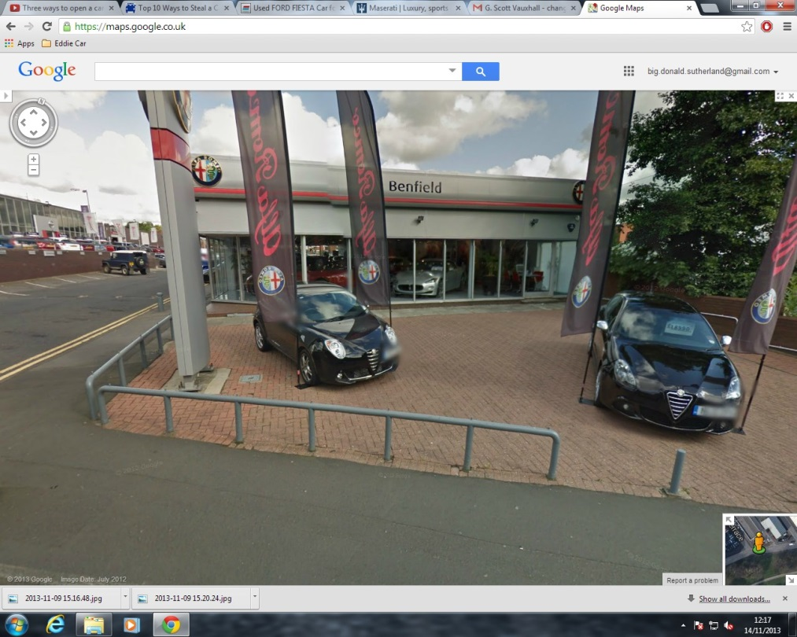

**2) Assignment\Donald Sutherland Home Computer\C\Users\Donald Sutherland\Documents\Car list.docx**

Using EnCase to search through files in Donald Sutherland’s user documents directory folder, a document called Car List.docx was found which includes the following list of cars. This implies Donald Sutherland’s interest in cars.

*1 1999 Aston Martin DB7 - Mary  
2 1962 Aston Martin DB1 - Barbara  
3 1999 Bentley Arnage - Lindsey  
4 1999 Bentley Azure - Laura  
5 1964 Bentley Continental - Alma  
6 1959 Cadillac El Dorado - Madeline  
7 1958 Cadillac El Dorado Brougham - Patricia  
8 1999 Cadillac Escalade - Carol  
9 2000 Cadillac El Dorado ETC (El Dorado Touring Coupe) - Daniela  
10 1957 Chevrolet Bel Air Convertible - Stefanie  
11 1969 Chevrolet Camaro Z28 - Erin  
12 1953 Chevrolet Corvette - Pamela  
13 1967 Chevrolet Corvette Stingray Big Block - Stacey  
14 2000 Ford F350 4x4 modified pick-up - Anne  
15 1971 DeTomaso Pantera - Kate  
16 1969 Dodge Daytona - Vanessa  
17 1998 Dodge Viper Coupe GTS - Denise  
18 1995 Ferrari 355 B - Diane  
19 1997 Ferrari 355 F1 - Iris  
20 1967 Ferrari 275 GTB4 - Nadine  
21 1999 Ferrari 550 Maranello - Angelina  
22 1987 Ferrari Testarossa - Rose  
23 1956 Ford T-Bird - Susan  
24 2000 GMC Yukon - Megan  
25 1999 HumVee 2-Door Pickup - Tracy  
26 1999 Infiniti Q45 - Rachel  
27 1994 Jaguar XJ 220 - Bernadene  
28 1999 Jaguar XK8 Coupe - Deborah  
29 1990 Lamborghini Diablo - Gina  
30 1999 Lexus LS 400 - Hillary  
31 1999 Lincoln Navigator - Kimberley  
32 1957 Mercedes Benz 300 SL/Gullwing - Dorothy  
33 1999 Mercedes Benz CL 500 - Donna  
34 1999 Mercedes Benz S 600 - Samantha  
35 1998 Mercedes Benz SL 600 - Ellen  
36 1950 Mercury Custom - Gabriela  
37 1971 Plymouth Hemi Cuda - Shannon  
38 1969 Plymouth Roadrunner - Jessica  
39 1965 Pontiac GTO - Sharon  
40 1999 Porsche 996 - Tina  
41 2000 Porsche Boxster - Marsha  
42 1961 Porsche Speedster - Natalie  
43 1988 Porsche 959 - Virginia  
44 1997 Porsche 911 Twin Turbo - Tanya  
45 2000 Rolls Royce Stretch Limousine - Grace  
46 1966 Shelby AC Cobra - Ashley  
47 1967 Shelby Mustang GT 500 - Eleanor  
48 2000 Toyota Landcruiser - Cathy  
49 1998 Toyota Supra Turbo - Lynn  
50 2000 Volvo Turbo Wagon R - Lisa*

**3) Assignment\Donald Sutherland Home Computer\C\Users\Donald Sutherland\Documents\Password.docx**

Using EnCase, the following file was found. It is a jpg file which has had its file extension changed in attempt to hide it and make it look like a Microsoft Word Document. Inside this jpg file, contains a password of Donald Sutherland’s, which has been used for a compressed zip file as exhibited below.



**4) Assignment\Donald Sutherland Home Computer\C\Users\Donald Sutherland\Pictures\Friend.zip**

Using case processor inside EnCase to search for protected files, a compressed file was found. The compressed .zip file is password protected and has been created using 7-zip.

The compressed file was extracted using EnCase a secure Forensic Workstation and it was then analyzed using ExifTool. Using the password above, the zip file was successfully unlocked. Inside this .zip file, a folder was found called “Fiona”.

Inside this Fiona folder, 13 images were found of suspicious pictures of a Ford Fiesta ST150 surveilled during the sunlight and then again surveilled at night in complete darkness. These pictures in the darkness give the impression that the pictures were taken just before the car was stolen.

The list of contents in the .zip file and these images can be found in the Appendices section at the end of this report.

## Using ExifTool to extract information out of one of the images, the following metadata was retrieved from inside the file:

**i) Assignment\Donald Sutherland Home Computer\C\Users\Donald Sutherland\Pictures\Friend.zip\Fiona\** **2013-11-17 17.14.15.jpg**

*K:\Uni\Digital Forensics Practice and Procedure\Assignment\Export\Pictures\Fiona>ExifTool.exe 2013-11-17_17.14.15.jpg*

*ExifTool Version Number : 10.40*

*File Name : 2013-11-17_17.14.15.jpg*

*File Size : 893 kB*

*File Modification Date/Time : 2013:11:17 17:14:14+00:00*

*File Access Date/Time : 2017:01:26 15:46:09+00:00*

*File Creation Date/Time : 2017:01:26 15:46:08+00:00*

*File Permissions : rw-rw-rw-*

*File Type : JPEG*

*File Type Extension : jpg*

*MIME Type : image/jpeg*

*Exif Byte Order : Little-endian (Intel, II)*

*Make : SAMSUNG*

*Camera Model Name : GT-S5830*

*Orientation : Horizontal (normal)*

*Software : S5830BUKC2*

*Modify Date : 2013:11:17 17:14:15*

*Y Cb Cr Positioning : Centered*

*Exposure Time : 1/8*

*F Number : 2.6*

*Exposure Program : Aperture-priority AE*

*ISO : 400*

*Exif Version : 0220*

*Date/Time Original : 2013:11:17 17:14:15*

*Create Date : 2013:11:17 17:14:15*

*Max Aperture Value : 2.8*

*Metering Mode : Center-weighted average*

*Flash : No Flash*

*Focal Length : 3.5 mm*

*User Comment : User comments*

*Color Space : sRGB*

*Exif Image Width : 2560*

*Exif Image Height : 1920*

*Exposure Mode : Auto*

*White Balance : Auto*

*Scene Capture Type : Standard*

*Compression : JPEG (old-style)*

*X Resolution : 72*

*Y Resolution : 72*

*Resolution Unit : inches*

*Thumbnail Offset : 604*

*Thumbnail Length : 9818*

*JFIF Version : 1.01*

*Comment : ..Ç.Ç.Ó.p*

*Image Width : 2560*

*Image Height : 1920*

*Encoding Process : Baseline DCT, Huffman coding*

*Bits Per Sample : 8*

*Color Components : 3*

*Y Cb Cr Sub Sampling : YCbCr4:2:2 (2 1)*

*Aperture : 2.6*

*Image Size : 2560x1920*

*Megapixels : 4.9*

*Shutter Speed : 1/8*

*Thumbnail Image : (Binary data 9818 bytes, use -b option to extract)*

*Focal Length : 3.5 mm*

*Light Value : 3.8*

As we can see from the extraction of this metadata, the picture has been taken using a mobile phone - a Samsung GT-25830. This is very important in identifying the individual who has taken the picture, along with the information of whether the car in the picture is now missing. If these pictures are further able to be found on Donald Sutherland’s device; a Samsung GT-25830, then this provides very supporting evidence of the following accusations of:

* *Conspiracy*
* *Pre-Meditation*
* *Theft*
* *Breaking and Entering*
* *Property Damage*

**ii) Assignment\Donald Sutherland Home Computer\C\Users\Donald Sutherland\Pictures\Friend.zip\Fiona\** **2013-11-18 09.02.52.jpg**

Appendix 9)this picture has been taken specifically to show the door lock of the surveilled car; the Ford Fiesta ST150. This implies heavily that the person taking the picture has intent of finding a way of gaining access to the car.

In this image, we can also see a reflection of the person who has taken the image. This may make it possible for further identifying Donald Sutherland as the person who has taken the image.

Let it be known, that when taking photos and saving them on your phone, they are automatically given a name based on the date and time which they were taken. The fact that these pictures have been found in the exact same names created by a phone camera on Donald Sutherland’s computer, and have been found together in a bundle, highly suggests that Donald Sutherland has taken them himself. Further logs may or may not show the pictures being copied from Donald Sutherland’s phone and onto his computer.

**5) Assignment\Donald Sutherland Home Computer\C\Users\Donald Sutherland\Pictures\new pub 1, Eye on the Tyne.png**

Appendix 14) A potential meeting place for Donald Sutherland and his associate. More coming later.

**6) Assignment\Donald Sutherland Home Computer\C\Users\Donald Sutherland\Pictures\new pub 2, The Quayside, spoons.png**

Appendix 15) A potential meeting place for Donald Sutherland and his associate. More coming later.

**7) Assignment\Donald Sutherland Home Computer\C\Users\Donald Sutherland\Pictures\new pub 3, The Slug and Lettace.png**

Appendix 16) A potential meeting place for Donald Sutherland and his associate. More coming later.

**8) Assignment\Donald Sutherland Home Computer\C\Users\Donald Sutherland\Pictures\Recon\Dream2_Location.png**

Appendix 17) Created exactly at the same time as Dream.png, and stored in the same reconnaissance folder, this picture shows a map of the Benfield Maserati garage in Newcastle, with what looks to be planning directions of how he plans to get to the garage, and how he plans on getting away after taking the car.

**9) Assignment\Donald Sutherland Home Computer\C\Users\Donald Sutherland\Pictures\Recon\free parking in newcastle.png**

Appendix 18) This is a picture of Donald Sutherland looking for free-parking facilities which may lack the general security of other car parks. We can see in the next image that the one of his main choice and interest seemed to be the Eldon Square multi-story building, with a map of it being shown. Created on 01/11/2013 at 13.53, this picture was created 13 days before the reconnaissance pictures of the Benfield garage in Newcastle.

**10) Assignment\Donald Sutherland Home Computer\C\Users\Donald Sutherland\Pictures\Recon\Eldon Square multi-storey.png**

Appendix 19) As shown in the appendix, this is a picture of a map of Eldon Square multi-story building in Newcastle which implies another target location of Donald Sutherland; the accused. Created 2 minutes after the previous image of Donald Sutherland looking for free parking facilities in Newcastle.

**11) Assignment\Donald Sutherland Home Computer\C\Users\Donald Sutherland\Pictures\Recon\G. Scott Cars, Askew Road.png**

Appendix 20) Created 4 days later, this image shows Donald Sutherland looking into a map of “G scott scars”; a possible potential target for his crimes, and possibly a sequel to the previous car thefts at Eldon Square multi story.

**14) Assignment\Donald Sutherland Home Computer\C\Users\Donald Sutherland\Pictures\Recon\Tyneside Autoparc, Sandy ln.png**

Appendix 21) Taken a few minutes after the previous Appendix 20, this picture is a map of Sandy Ln in Newcastle which further contains a Google Chrome tab open linked to an eBay auction of a Volkswagen motor vehicle. From what we can tell, this is made out be as if Donald Sutherland has found an auction of a car he wants in the Newcastle region, stored the location of the car in an image, and then pursued and stolen the vehicle.

**15) Assignment\Donald Sutherland Home Computer\C\Users\Donald Sutherland\Pictures\Lottery Garage\payday.jpg\ZIP Volume\WP_20131121_006.jpg**

**16) Assignment\Donald Sutherland Home Computer\C\Users\Donald Sutherland\Pictures\Lottery Garage\payday.jpg\ZIP Volume\WP_20131121_008.jpg**

**17) Assignment\Donald Sutherland Home Computer\C\Users\Donald Sutherland\Pictures\Lottery Garage\payday.jpg\ZIP Volume\WP_20131121_009.jpg**

Appendix 22, 23 and 24) Using Encase, a file called payday.jpg has been found, with whilst being disguised as a jpg file, actually is a compressed .zip volume and contains images. Appendix 22 shows the first of 3 of these images, in which we can see are photos taken at night time of the car garage, followed by further pictures, appendix 23 and 24 showing further angles of the car garage.

**18) Assignment\Donald Sutherland Home Computer\C\Users\Donald Sutherland\Downloads\How To Unlock Car Door Without Key or Slim Jim.mp4**

An mp4 file has been found on Donald Sutherland’s computer, in his internet download folder; a YouTube video of a person giving step by step instructions on how to unlock a car without a key.

**19) Assignment\Donald Sutherland Home Computer\C\Users\Donald Sutherland\NTUSER.DAT**

Using EnCase to search through the central hierarchical database of Microsoft Windows, known as the registry, the following critical information has been found.

*Device Class ID: Disk&Ven_SAMSUNG&Prod_GT-S5830_Card&Rev_ffff*

*Serial Number: S5830b8e25db1*

*Friendly Name: SAMSUNG GT-S5830 Card USB Device*

*Associated User Accounts: Donald Sutherland*

*Last Assigned Drive Letter: I:*

*Last Connected Date/Time - (UTC) (dd/MM/yyyy): 18/11/2013 11:46:24*

*First Connected Date/Time - Local Time (yyyy-mm-dd): 2013-11-07 12:23:20*

*First Connect Since Reboot Date/Time - (UTC) (dd/MM/yyyy): 18/11/2013 11:45:04*

*Install Date/Time - (UTC) (dd/MM/yyyy): 07/11/2013 12:23:21*

*First Install Date/Time - (UTC) (dd/MM/yyyy): 07/11/2013 12:23:21*

*Class: DiskDrive*

*Device Description: @disk.inf,%disk_devdesc%;Disk drive*

*Manufacturer: @disk.inf,%genmanufacturer%;(Standard disk drives)*

*Volume GUID: {9f50ccf0-47a4-11e3-9987-00215ac5474b}*

*VSN Decimal: 2417381112*

*VSN Hex: 90164EF8*

*Source:*

*WMAMD1936927.E01 - Partition 1 (Microsoft NTFS, 74.53 GB) (All Files and Folders) - [ROOT]\Windows\System32\config\SYSTEM, WMAMD1936927.E01 - Partition 1 (Microsoft NTFS, 74.53 GB) (All Files and Folders) - [ROOT]\Users\Donald Sutherland\ntuser.dat,*

*WMAMD1936927.E01 - Partition 1 (Microsoft NTFS, 74.53 GB) (All Files and Folders) - [ROOT]\Windows\System32\config\software, WMAMD1936927.E01 - Partition 1 (Microsoft NTFS, 74.53 GB) (All Files and Folders) - [ROOT]\Windows\inf\setupapi.dev.log*

*Located At:*

*Registry Key:*

*HKLM\SYSTEM\ControlSet001\Enum\USBSTOR\Disk&Ven_SAMSUNG&Prod_GT-S5830_Card&Rev_ffff\S5830b8e25db1&0,*

*Registry Key:*

*HKLM\SYSTEM\MountedDevices,*

*Registry Key:*

*HKLM\SYSTEM\ControlSet001\Control\DeviceClasses\{53f56307-b6bf-11d0-94f2-00a0c91efb8b}\##?#USBSTOR#Disk&Ven_SAMSUNG&Prod_GT-S5830_Card&Rev_ffff#S5830b8e25db1&0#{53f56307-b6bf-11d0-94f2-00a0c91efb8b},*

*Registry Key:*

*HKLM\System\ControlSet001\Enum\USBSTOR\Disk&Ven_SAMSUNG&Prod_GT-S5830_Card&Rev_ffff\S5830b8e25db1&0\Properties\{83da6326-97a6-4088-9453-a1923f573b29}\00000064\00000000,*

*Registry Key:*

*HKLM\System\ControlSet001\Enum\USBSTOR\Disk&Ven_SAMSUNG&Prod_GT-S5830_Card&Rev_ffff\S5830b8e25db1&0\Properties\{83da6326-97a6-4088-9453-a1923f573b29}\00000065\00000000,*

*Registry Key:*

*HKU\S-1-5-21-601739683-2125448060-1724766464-1001\Software\Microsoft\Windows\CurrentVersion\Explorer\MountPoints2\{9f50ccf0-47a4-11e3-9987-00215ac5474b},*

*Registry Key:*

*HKLM\SOFTWARE\Microsoft\Windows NT\CurrentVersion\EMDMgmt, n/a*

*Evidence Number WMAMD1936927*

This provides us with the certifiable knowledge that, *SAMSUNG GT-S5830 with serial code “S5830b8e25db1”* has been used to take the pictures provided to us Appendix 2 – Evidence – section 4.The exact photos of the suspected missing car that were located on his computer, have come from and been taken from the exact same phone connected to his computer. Whether somebody else has been using Donald Sutherland’s computer, for weeks and weeks in his private home owned with his wife, to plan and record the acts of theft, conspiracy, pre-meditation, breaking and entering and property damage – I will let you be the judge of.

We however have seen evidence of him being logged into his own personal gmail account – [big.donald.sutherland@gmail.com](mailto:big.donald.sutherland@gmail.com) – whilst creating reconnaissance images of the suspected car thieved garages in question, further implying that on top of a stranger coming to use his computer somehow without his and his wife’s knowledge – for weeks and weeks, has further gained access his gmail account.

Whether the phone in question; *SAMSUNG GT-S5830* with the serial number of, S5830b8e25db1; is Donald Sutherland’s phone, is still to be discovered. I will let you be the judge of the probability. However this brings us to the next section 20 of Appendix 2 – Evidence.

**20) Assignment\Donald Sutherland Home Computer\C\** **Windows\System32\config\SOFTWARE**

By doing a search with Internet Evidence Finder, we have found out the following crucial information about the User Account; Donald Sutherland.

*User Name: Donald Sutherland*

*Type of User: Local User*

*Security Identifier: S-1-5-21-601739683-2125448060-1724766464-1001*

*Profile Path: C:\Users\Donald Sutherland*

*Last Login Date/Time - (UTC) (dd/MM/yyyy): 22/11/2013 10:49:59*

*Last Password Change Date/Time - (UTC) (dd/MM/yyyy) : 25/10/2013 12:20:33*

*Password Required: True*

*LM Hash (not found)*

*NTLM Hash: C4879B58CD51A636D0FD2556F518F7FC*

*User Group(s): Administrators, HomeUsers*

*Login ScriptL (not found)*

*Last Incorrect Password Login Date/Time - (UTC) (dd/MM/yyyy): 15/11/2013 10:52:17*

*Login Coun:t 17*

*Account Disabled: False*

*Source:*

*WMAMD1936927.E01 - Partition 1 (Microsoft NTFS, 74.53 GB) (All Files and Folders) - [ROOT]\Windows\System32\config\SAM, WMAMD1936927.E01 - Partition 1 (Microsoft NTFS, 74.53 GB) (All Files and Folders) - [ROOT]\Windows\System32\config\software*

*Located At:*

*Registry Key: SAM\Domains\Account\Users\000003E9,*

*Registry Key: SAM\Domains\Builtin\Aliases\00000220,*

*Registry Key: SAM\Domains\Account\Aliases\000003EA,*

*Registry Key: HKLM\Software\Microsoft\Windows*

*NT\CurrentVersion\ProfileList\S-1-5-21-601739683-2125448060-1724766464-1001*

*Evidence Number: WMAMD1936927*

This information shows certifiable evidence that Donald Sutherland’s user account that has been used to carry out the planning and recording of theft, is password protected and requires the password to be inputted each time. This further shows that during the weeks of the theft planning and recording, his User Account has been logged in to 17 times, exhibiting completely the fact that his password has beyond all reasonable doubt been required and used to carry out the planning and recording of the criminally accused car thefts. For each Login Count; this confirms beyond all reasonable doubt that his account has been logged out of 17 times during the time period of the car thefts and planning, concluding to the only given fact that the person accessing his computer, will have HAD to have access to his password.

With this continued, ladies and gentlemen of the jury, it is shown that that it is not possible for the planning and recording of the crimes to have been done remotely, with the sole fact that the recording of the car thefts being inputted into his computer from directly a physical device; a *SAMSUNG GT-S5830.*

*With my sole expertise being purely for evidence gathering, in support of the accused crimes, explaining the relevance to the accused; I leave the probability and judgment of this evidence completely in your hands. Thank for you for reading. On the following pages you will find the Appendices attached.*

Appendices

**1) Assignment\Donald Sutherland Home Computer\C\Users\Donald Sutherland\Pictures\Friend.zip\Fiona\** **2013-11-17 17.10.57.jpg**

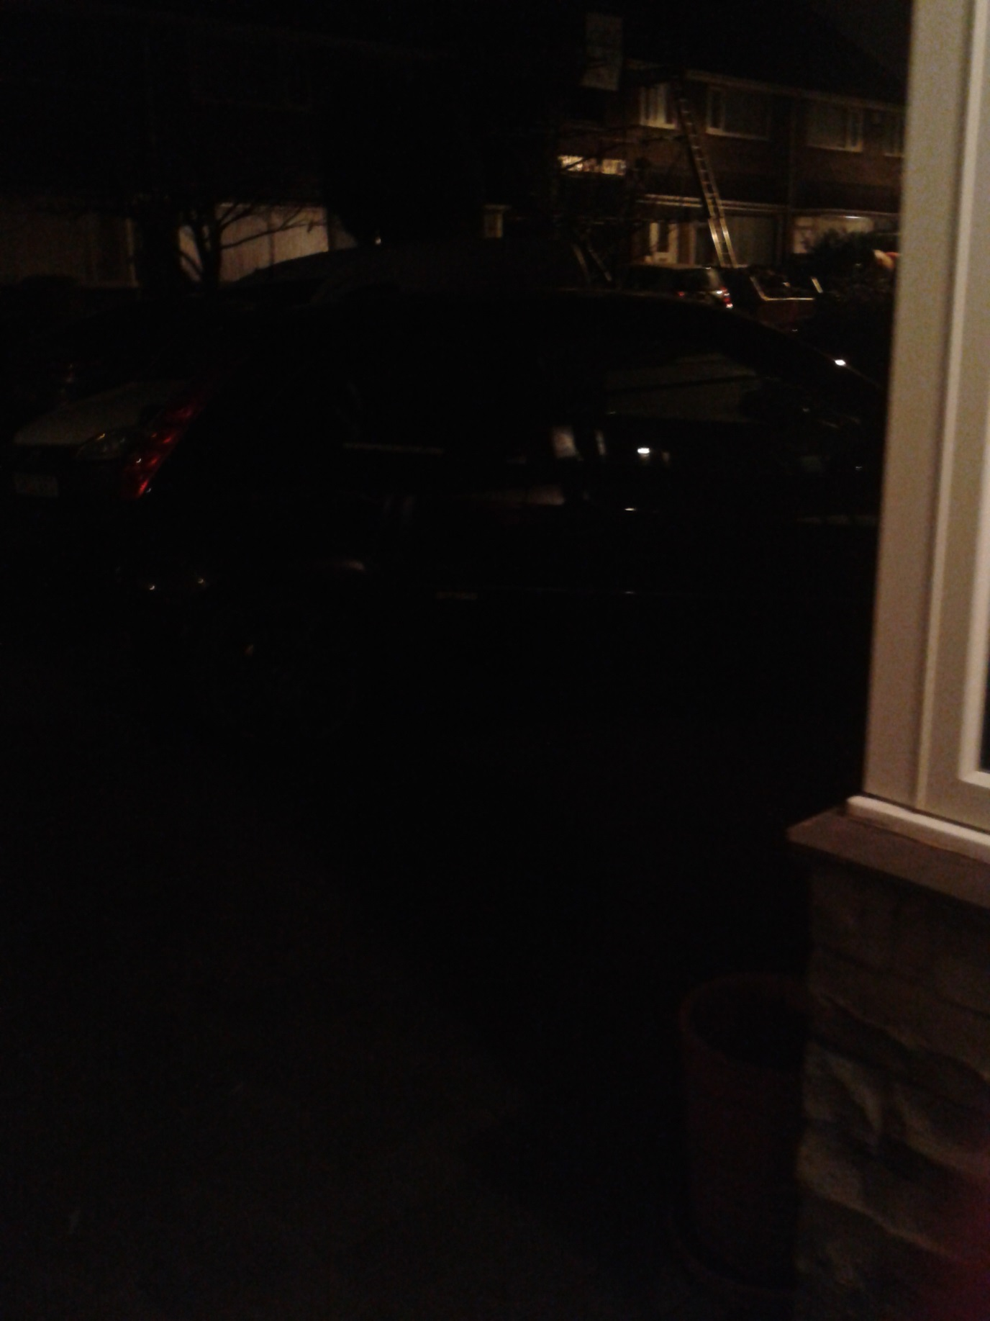

**2) Assignment\Donald Sutherland Home Computer\C\Users\Donald Sutherland\Pictures\Friend.zip\Fiona\** **2013-11-17 17.11.13.jpg**

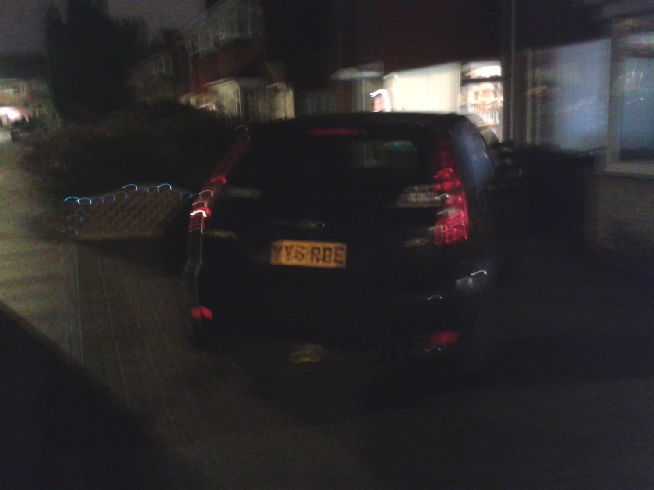

**3) Assignment\Donald Sutherland Home Computer\C\Users\Donald Sutherland\Pictures\Friend.zip\Fiona\** **2013-11-17 17.11.42.jpg**

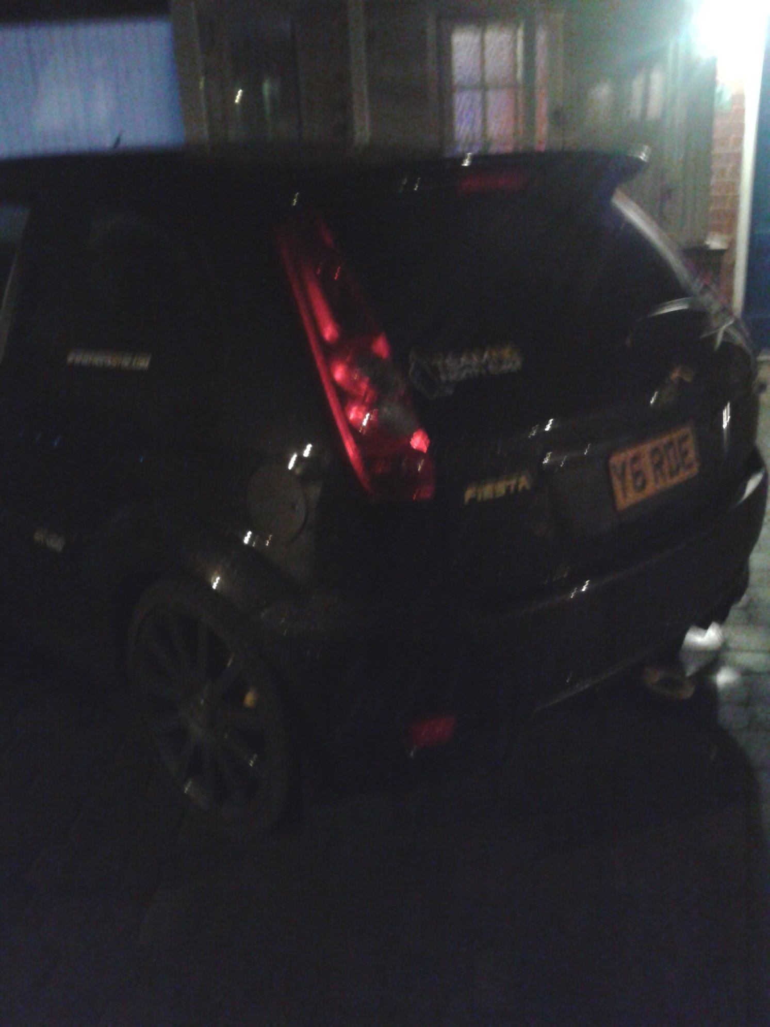

**4) Assignment\Donald Sutherland Home Computer\C\Users\Donald Sutherland\Pictures\Friend.zip\Fiona\** **2013-11-17 17.14.15.jpg**

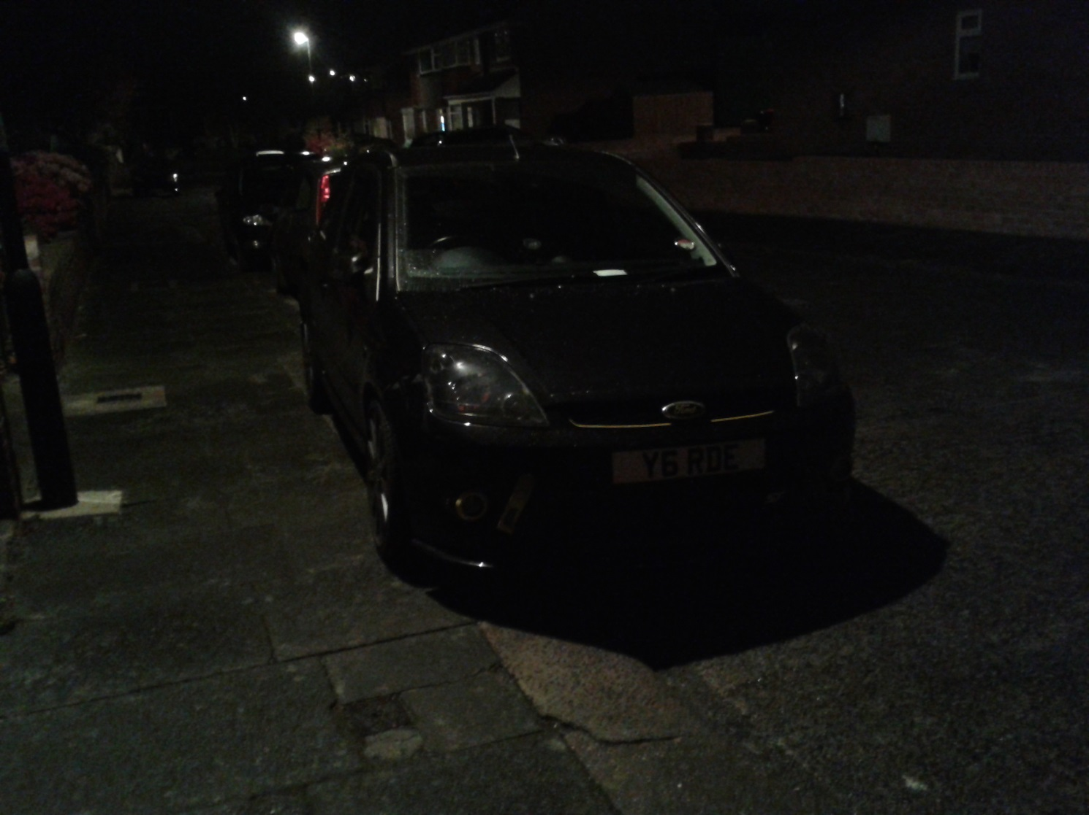

**5) Assignment\Donald Sutherland Home Computer\C\Users\Donald Sutherland\Pictures\Friend.zip\Fiona\** **2013-11-17 17.14.27.jpg**

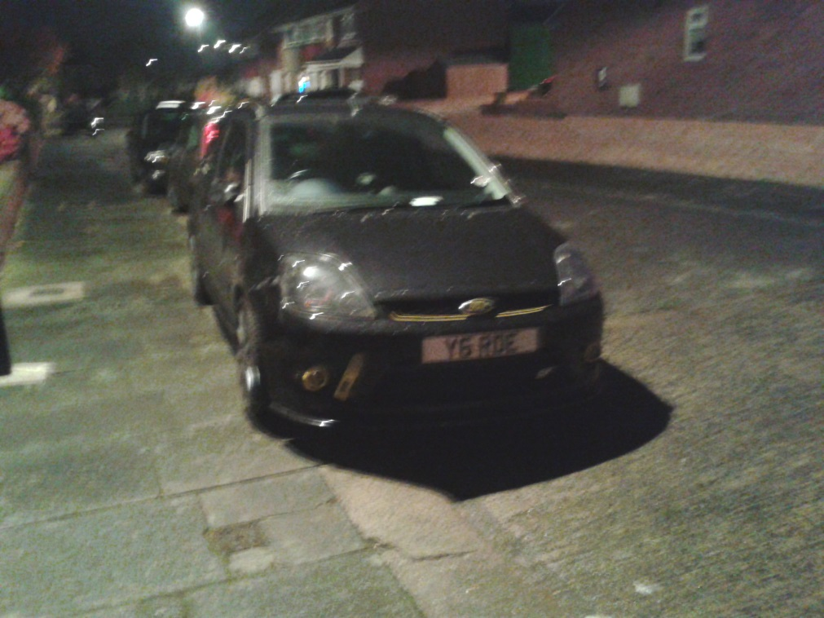

**6) Assignment\Donald Sutherland Home Computer\C\Users\Donald Sutherland\Pictures\Friend.zip\Fiona\** **2013-11-17 17.14.47.jpg**

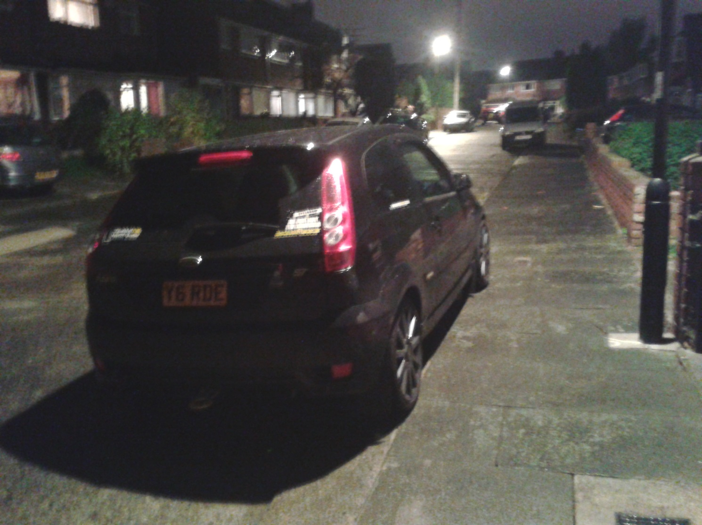

**7) Assignment\Donald Sutherland Home Computer\C\Users\Donald Sutherland\Pictures\Friend.zip\Fiona\** **2013-11-18 09.02.33.jpg**

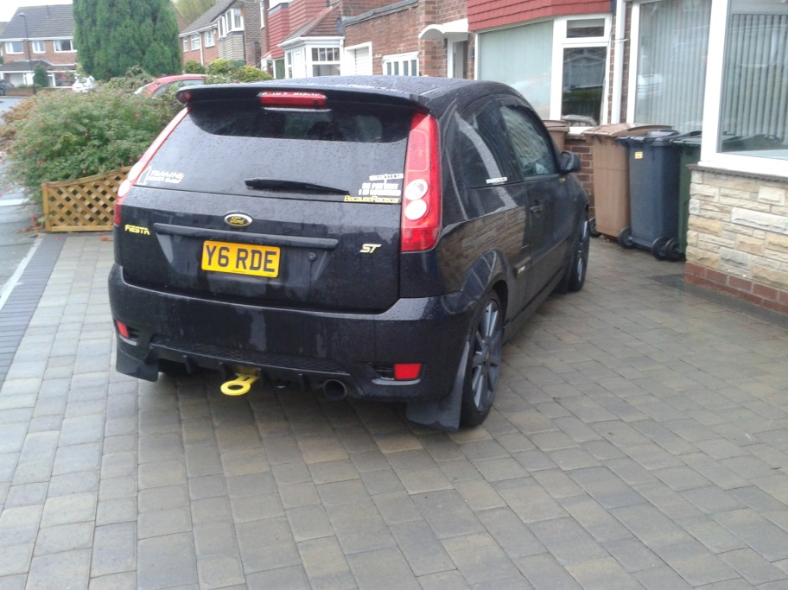

**8) Assignment\Donald Sutherland Home Computer\C\Users\Donald Sutherland\Pictures\Friend.zip\Fiona\** **2013-11-18 09.02.42.jpg**

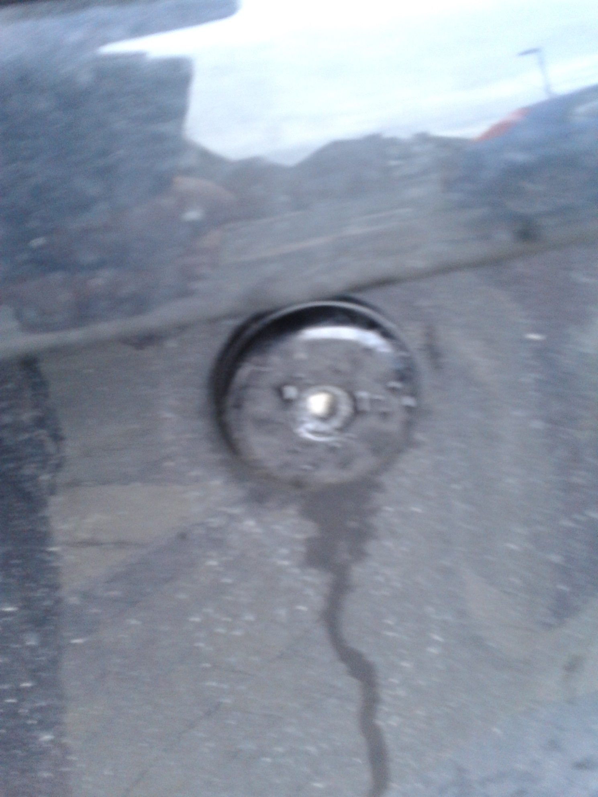

**9) Assignment\Donald Sutherland Home Computer\C\Users\Donald Sutherland\Pictures\Friend.zip\Fiona\** **2013-11-18 09.02.52.jpg**

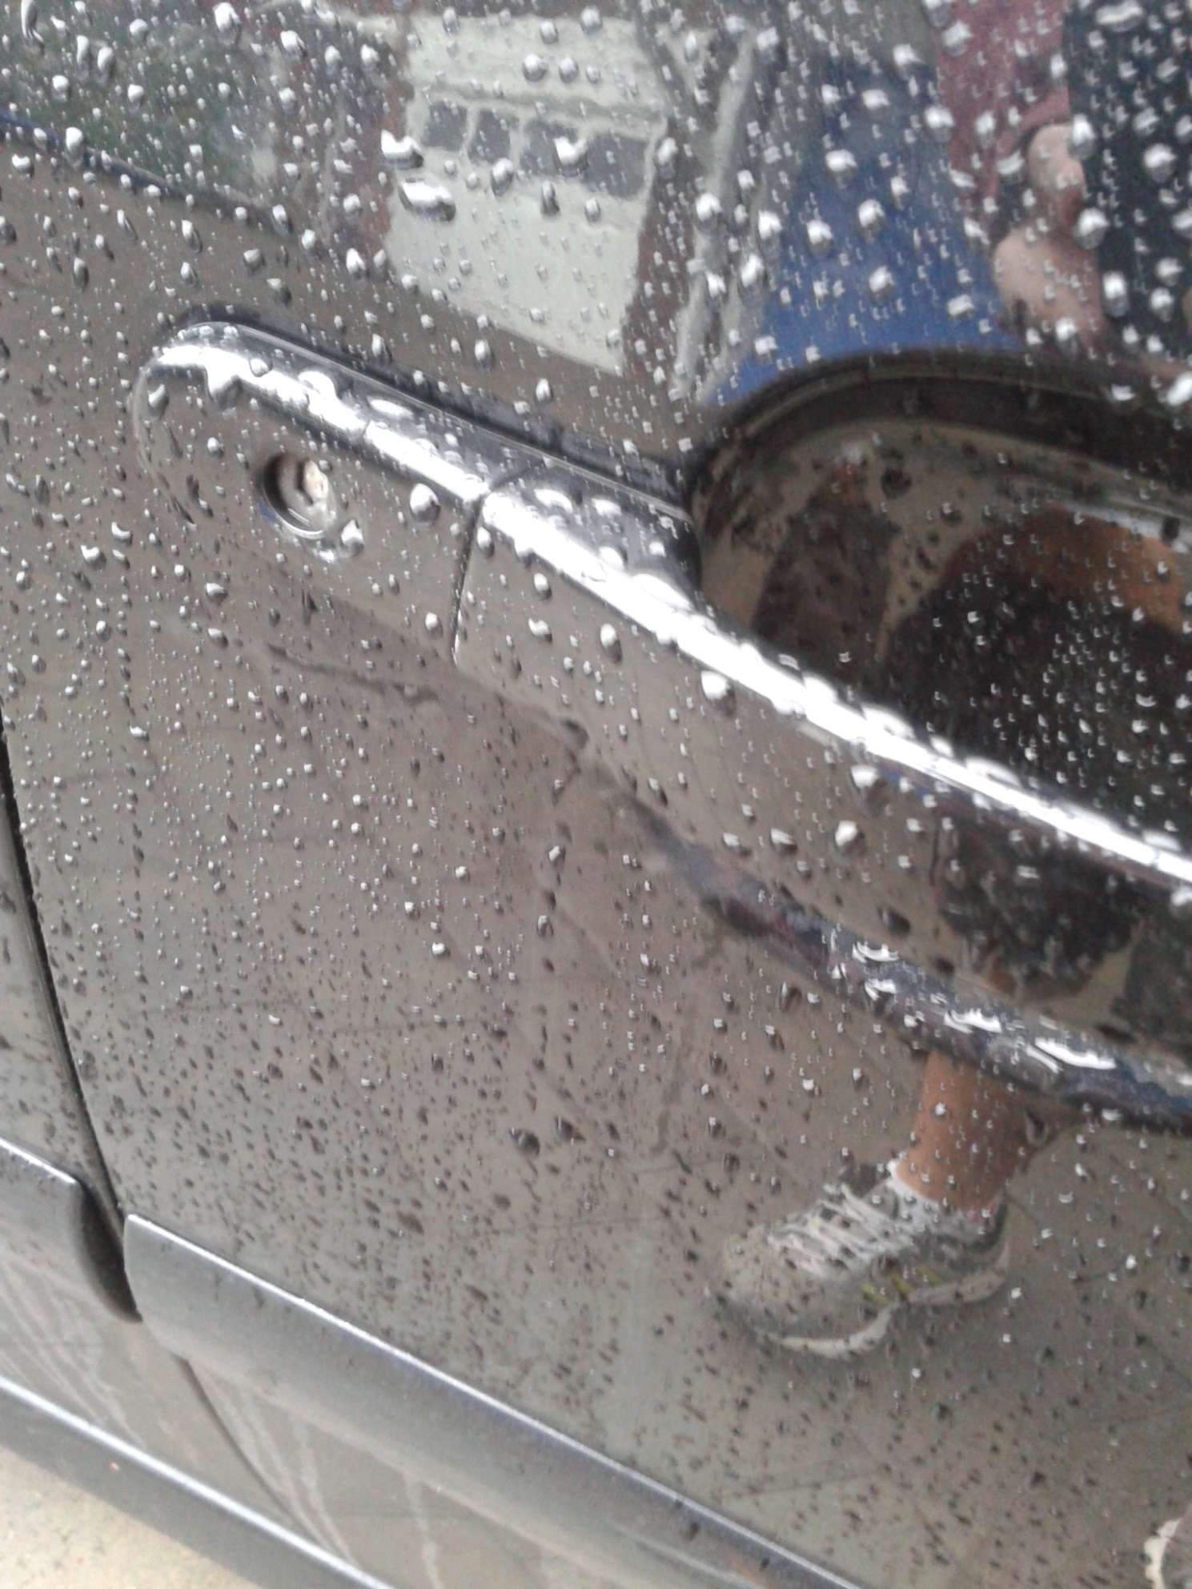

**10) Assignment\Donald Sutherland Home Computer\C\Users\Donald Sutherland\Pictures\Friend.zip\Fiona\** **2013-11-18 09.03.03.jpg**

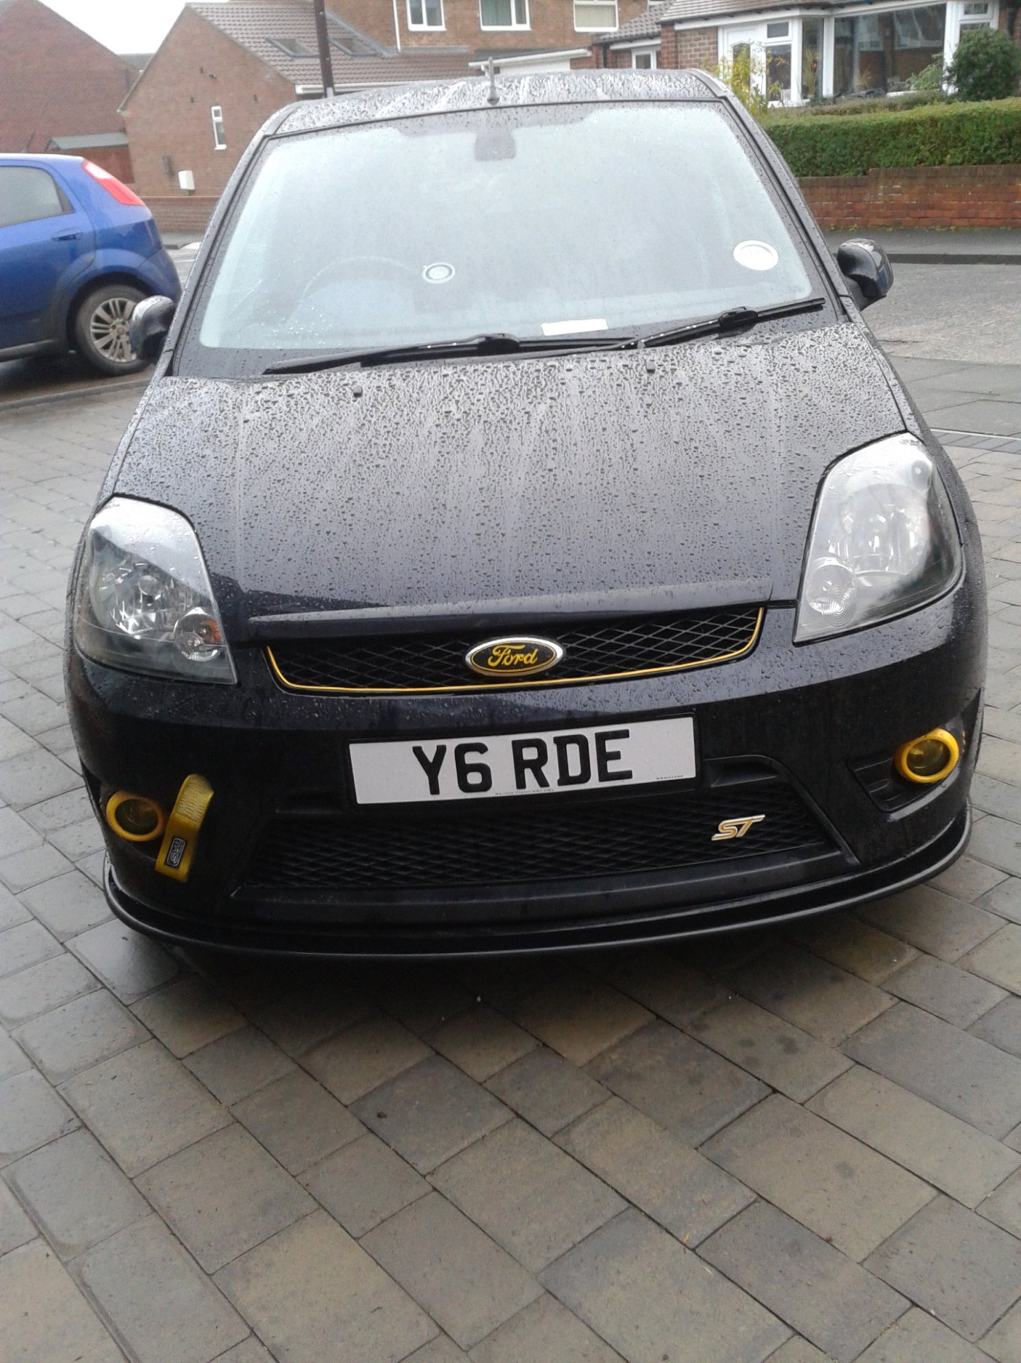

**11) Assignment\Donald Sutherland Home Computer\C\Users\Donald Sutherland\Pictures\Friend.zip\Fiona\** **2013-11-18 09.03.17.jpg**

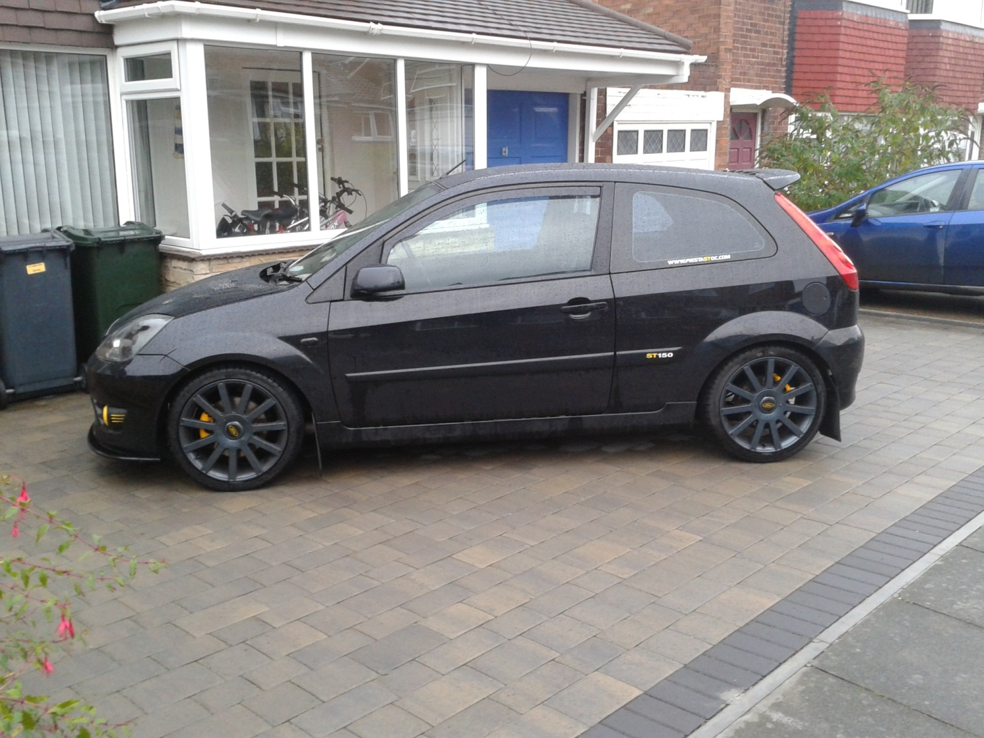

**12) Assignment\Donald Sutherland Home Computer\C\Users\Donald Sutherland\Pictures\Friend.zip\Fiona\** **2013-11-18 09.03.26.jpg**

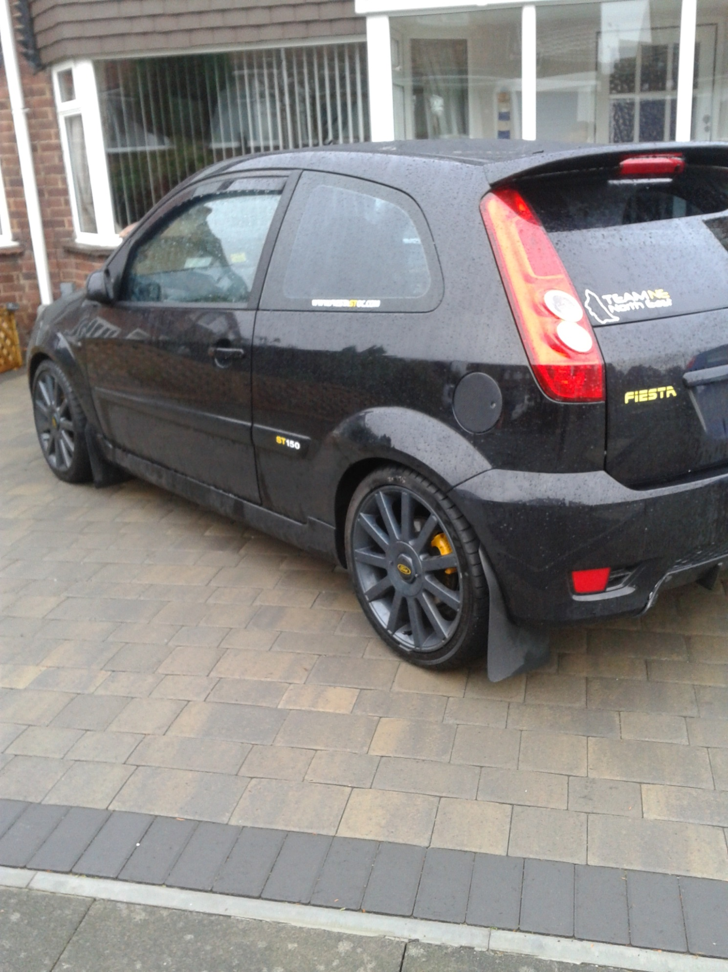

**13) Assignment\Donald Sutherland Home Computer\C\Users\Donald Sutherland\Pictures\Friend.zip\Fiona\** **2013-11-18 09.03.30.jpg**

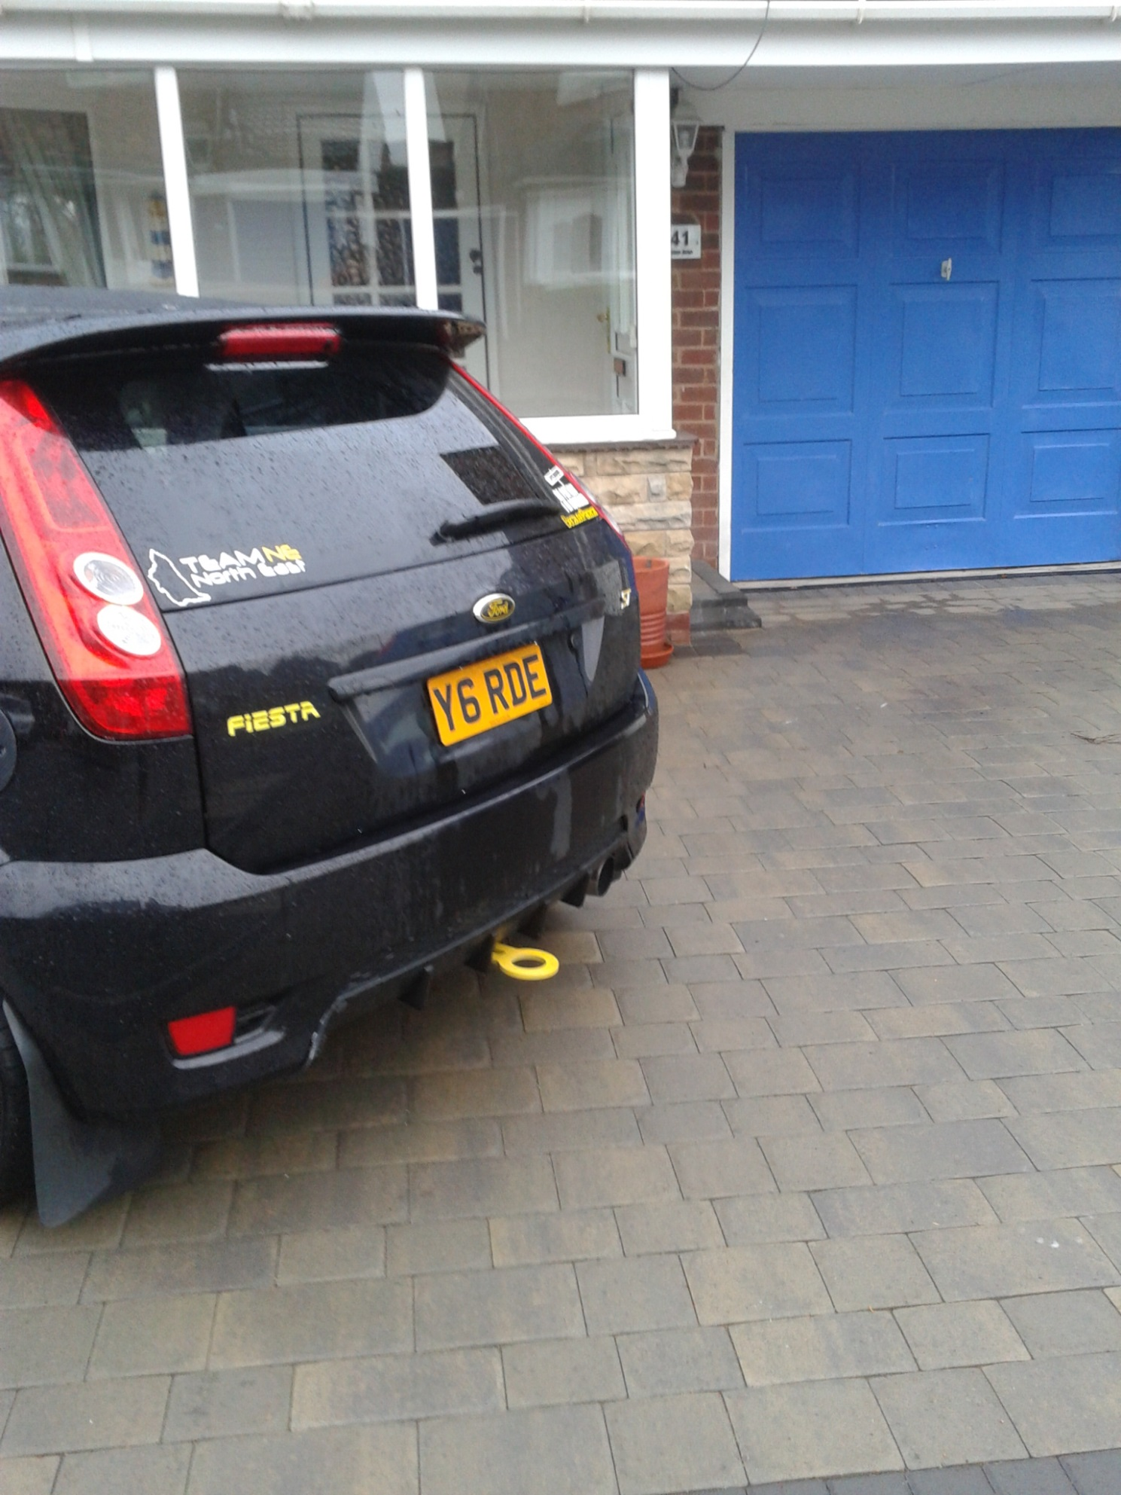

**14) Assignment\Donald Sutherland Home Computer\C\Users\Donald Sutherland\Pictures\new pub 1, Eye on the Tyne.png**

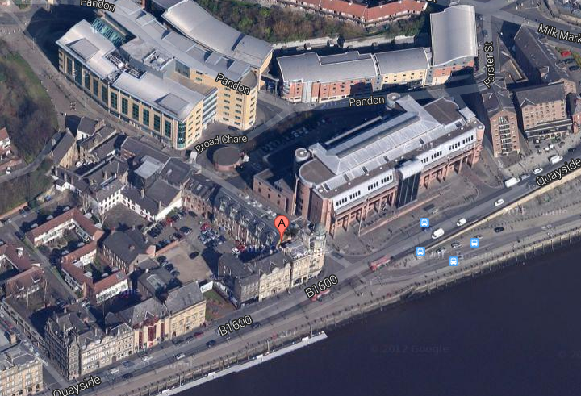

**15) Assignment\Donald Sutherland Home Computer\C\Users\Donald Sutherland\Pictures\new pub 2, The Quayside, spoons.png**

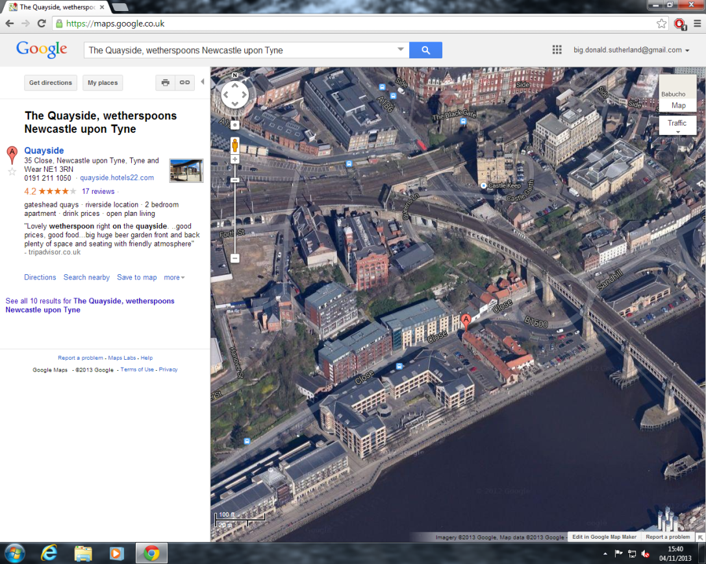

**16) Assignment\Donald Sutherland Home Computer\C\Users\Donald Sutherland\Pictures\new pub 3, The Slug and Lettace.png**

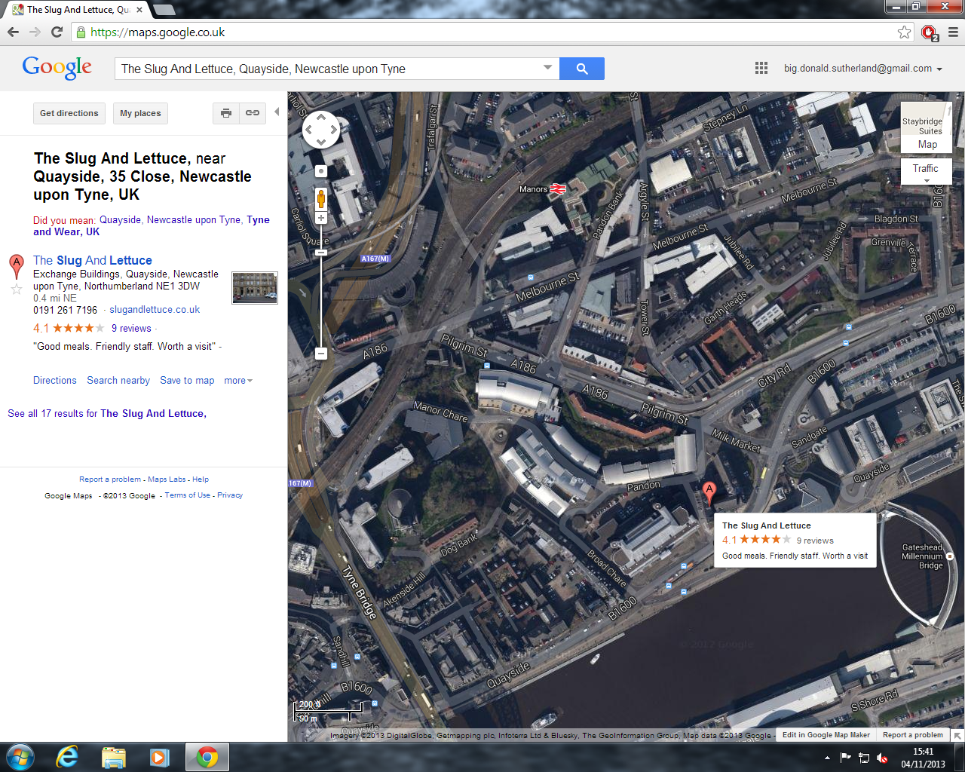

**17) Assignment\Donald Sutherland Home Computer\C\Users\Donald Sutherland\Pictures\Recon\Dream2_Location.png**

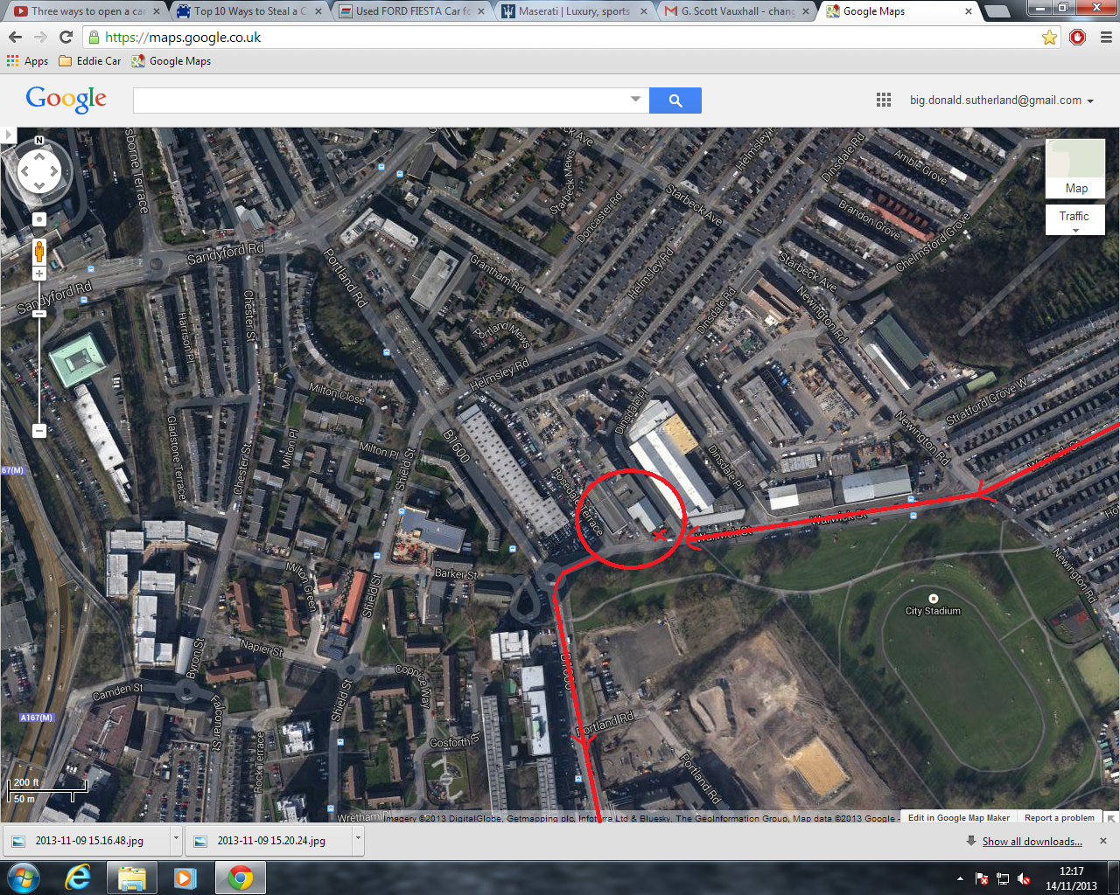

**18) Assignment\Donald Sutherland Home Computer\C\Users\Donald Sutherland\Pictures\Recon\free parking in newcastle.png**

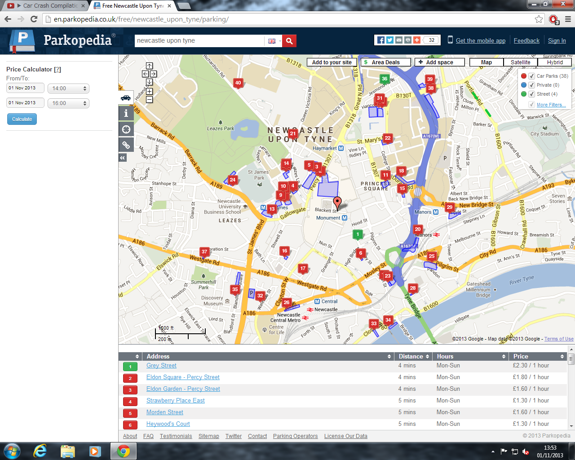

**10) Assignment\Donald Sutherland Home Computer\C\Users\Donald Sutherland\Pictures\Recon\Eldon Square multi-storey.png**

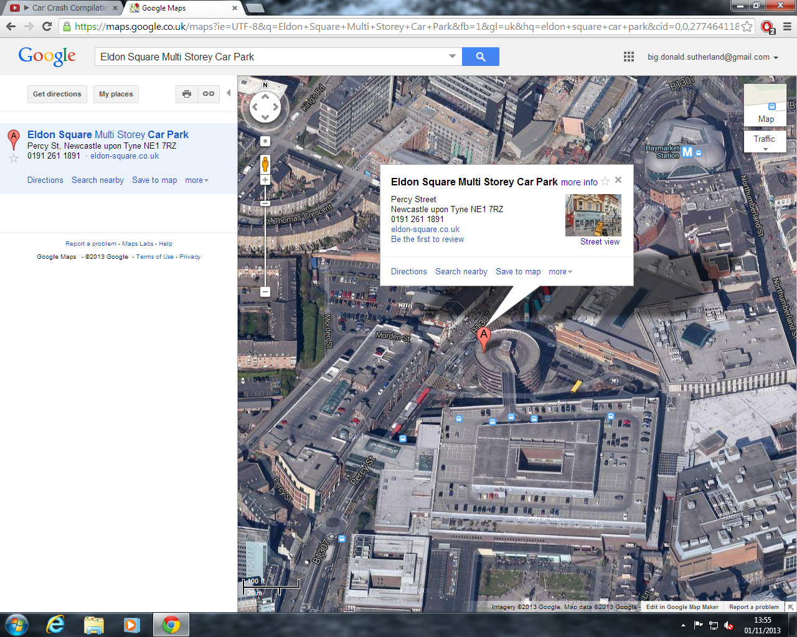

**20) Assignment\Donald Sutherland Home Computer\C\Users\Donald Sutherland\Pictures\Recon\G. Scott Cars, Askew Road.png**

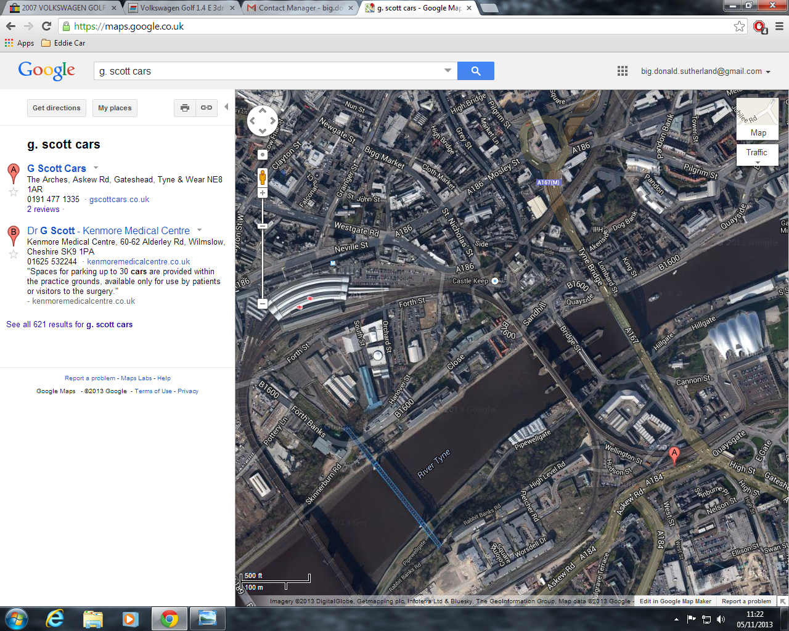

**21) Assignment\Donald Sutherland Home Computer\C\Users\Donald Sutherland\Pictures\Recon\Tyneside Autoparc, Sandy ln.png**

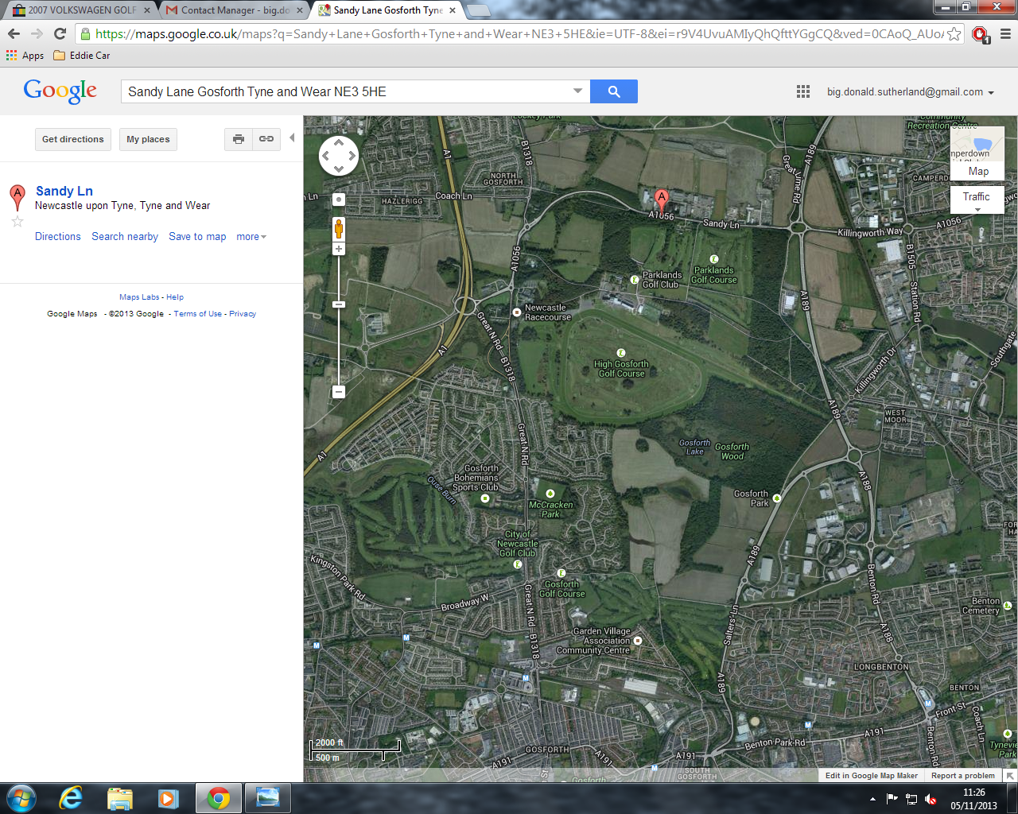

**22) Assignment\Donald Sutherland Home Computer\C\Users\Donald Sutherland\Pictures\Lottery Garage\payday.jpg\ZIP Volume\WP_20131121_006.jpg**

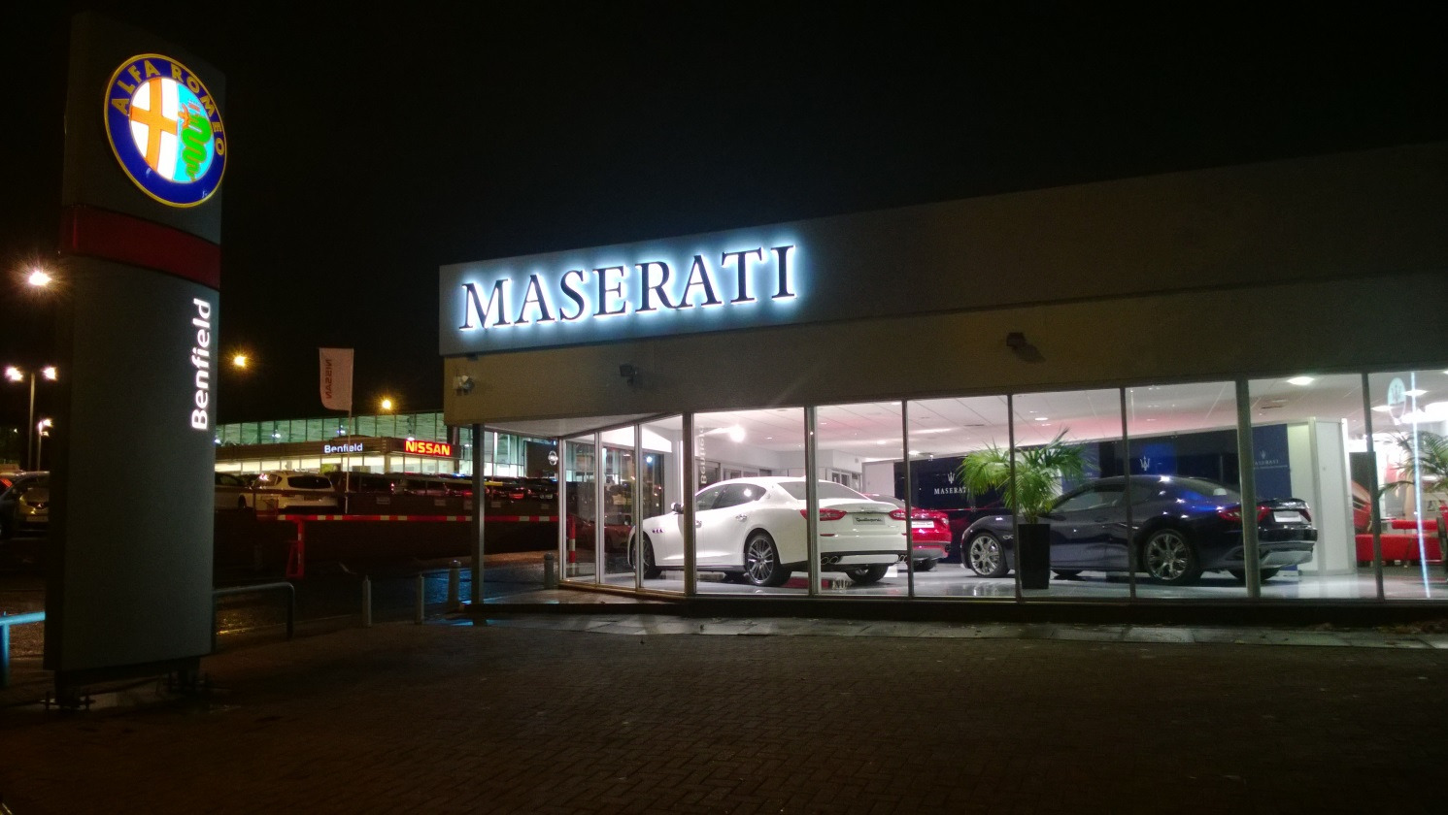

**23) Assignment\Donald Sutherland Home Computer\C\Users\Donald Sutherland\Pictures\Lottery Garage\payday.jpg\ZIP Volume\WP_20131121_008.jpg**

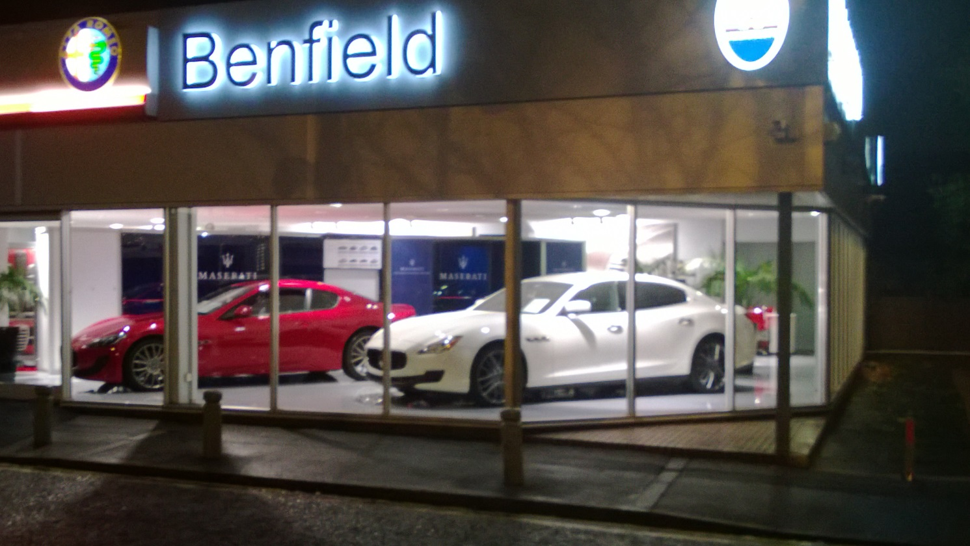

**24) Assignment\Donald Sutherland Home Computer\C\Users\Donald Sutherland\Pictures\Lottery Garage\payday.jpg\ZIP Volume\WP_20131121_009.jpg**

